**MINI PROJECT**

**(2020-21)**

**QUIZ MANIA**

**MID – TERM REPORT**

Department of Computer Engineering & Applications

**Institute of Engineering & Technology**



**GLA University**

**Mathura- 281406, INDIA**

**2020**

**Submitted By:**  **Submitted To:** Vijay Kumar Tyagi Mr. Anand Gupta

Saurabh Saraswat Mrs. Ruchi Gupta

Bhanu Pratap Singh

Tanesh Gupta

Prateek Sharma

**ABSTRACT** **3**

**INTRODUCTION** **4**

What exactly is QuizMania ? 4

What is MERN stack ? 4

MongoDB 5

Advantages of MongoDB 5

Express JS 6

Advantages Of Express JS 6

React 7

Advantages of React 7

Node.js 8

Advantages Of Node.js 8

Why MERN Stack ? 8

HARDWARE AND SOFTWARE REQUIREMENTS 9

Hardware Requirements: 9

Software Requirements : 9

DATABASE STRUCTURE 10

Main Database Schema (Quizzes) 10

# **ABSTRACT**

In this project we are going to build a real-time quiz website which can create quizzes competitively and collaboratively by students for the purpose of reducing the load required for a teacher and promoting interactions among students and between the teacher and students.

The Website is based upon the latest MERN stack technology

Many Colleges, Institutes and academic centers work in manual mode for taking examinations. This is time consuming as well as resource consuming. All such operations are handled on test copies, files or registers manually. This project intends to use the latest advancements in information technology and provide a central web solution for automating some basic examination.This will help many stakeholders of a college, institute or school to quickly do examinations online.

# **INTRODUCTION**

## What exactly is QuizMania ?

QuizMania is a Web Application based on MERN stack i.e., MongoDB, Express, React NodeJS.

.

The Website allows you to create Quiz and host it online. The website is real time as well as Multiplayer means the score is calculated instantly and more than 1 player can take the Quiz.

## What is MERN stack ?

**MERN Stack:** MERN Stack is a Javascript Stack

that is used for easier and faster deployment of

full-stack web applications. MERN Stack comprises

4 technologies namely: [MongoDB](https://www.geeksforgeeks.org/mongodb-an-introduction/), [Express](https://www.geeksforgeeks.org/introduction-to-express/), [React](https://www.geeksforgeeks.org/react-js-introduction-working/)

and [Node.js.](https://www.geeksforgeeks.org/introduction-to-nodejs/) It is designed to make the development process smoother and easier.

Each of these 4 powerful technologies provides an

end-to-end framework for the developers to work

in and each of these technologies play a big part in the

development of web applications

### MongoDB

MongoDB is a NoSQL database where each record is a document consisting of key-value pairs that are similar to JSON (JavaScript Object Notation) objects. MongoDB is flexible and allows its users to create schema, databases, tables, etc. Documents that are identifiable by a primary key make up the basic unit of MongoDB. Once MongoDB is installed, users can make use of Mongo Shell as well. Mongo shell provides a JavaScript interface through which the users can interact and carry out operations (eg: querying, updating records, deleting records.

#### Advantages of MongoDB

* Fast – Being a document-oriented database, easy to index documents. Therefore a faster response.
* Scalability – Large data can be handled by dividing it into several machines.
* Use of JavaScript – MongoDB uses JavaScript which is the biggest advantage.
* Schema Less – Any type of data in a separate document.
* Data stored in the form of JSON –
  1. Objects, Object Members, Arrays, Values and Strings
  2. JSON syntax is very easy to use.
  3. JSON has a wide range of browser compatibility.
  4. Sharing Data: Data of any size and type(video, audio) can be shared easily.
* Simple Environment Setup – It's really simple to set up MongoDB.
* Flexible Document Model – MongoDB supports document-model(tables, schemas, columns & SQL) which is faster and easier.
* **Creating a database: Simply done using a “use” command:**

### Express JS

Express is a Node.js framework. Rather than writing the code using Node.js and creating loads of Node modules, Express makes it simpler and easier to write the back-end code. Express helps in designing great web applications and APIs. Express supports many middlewares which makes the code shorter and easier to write

#### Advantages Of Express JS

* Asynchronous and Single-threaded.
* Efficient, fast & scalable
* Has the biggest community for Node.js
* Express promotes code reusability with its built-in router.
* Robust API
* Create a new folder to start your express project and type below command in the command prompt to initialize a package.json file. Accept the default settings and continue.

### React

React is a JavaScript library that is used for building user interfaces. React is used for the development of single-page applications and mobile applications because of its ability to handle rapidly changing data. React allows users to code in JavasScript and create UI components

#### Advantages of React

* Virtual DOM – A virtual DOM object is a representation of a DOM object. Virtual DOM is actually a copy of the original DOM. Any modification in the web application causes the entire UI to re-render the virtual DOM. Then the difference between the original DOM and this virtual DOM is compared and the changes are made accordingly to the original DOM.
* JSX – Stands for JavaScript XML. It is an HTML/XML JavaScript Extension which is used in React. Makes it easier and simpler to write React components.
* Components – ReactJS supports Components. Components are the building blocks of UI wherein each component has a logic and contributes to the overall UI. These components also promote code reusability and make the overall web application easier to understand.
* High Performance – Features like Virtual DOM, JSX and Components makes it much faster than the rest of the frameworks out there.
* Developing Android/Ios Apps – With React Native you can easily code Android-based or IOS-Based apps with just the knowledge of JavaScript and ReactJS.
* You can start your react application by first installing “create-react-app” using npm or yarn.

### Node.js

Node.js provides a JavaScript Environment which allows the user to run their code on the server (outside the browser). Node pack manager i.e. npm allows the user to choose from thousands of free packages (node modules) to download.

#### Advantages Of Node.js

* Open source JavaScript Runtime Environment
* Single threading – Follows a single threaded model.
* Data Streaming
* Fast – Built on Google Chrome’s JavaScript Engine, Node.js has a fast code execution.
* Highly Scalable
* Initialize a Node.js application by typing running the below command in the command window. Accept the standard settings.

## Why MERN Stack ?

* The speed of design and development of websites and web applications,
* Reducing server costs,
* The performance of greatly optimized web applications and software,
* The ease of transposing a web application to a mobile application or software, thanks in particular to React Native,
* The luxury of designing a website using a single HTML document,
* The development of a computer application using a single language, JavaScript.

## HARDWARE AND SOFTWARE REQUIREMENTS

### Hardware Requirements:

* RAM:- 4.00GB ·
* Processor:- Intel(R)Core(TM) i3-4005U CPU @ 1.70GHz

### Software Requirements :

* VSCode text editor for creating API. ·
* Node js for hosting server on localhost .
* RoboMongo 3T for visual representation of Database

## DATABASE STRUCTURE

* There are two database models to be used in the project one as a main database and one as a backup
* The user has a direct Interaction with the main database but No access to the backup database in granted to the user for keeping data safe
* The data in the backup database is saved automatically and instantly when the main database is updated

### Main Database Schema (Quizzes)

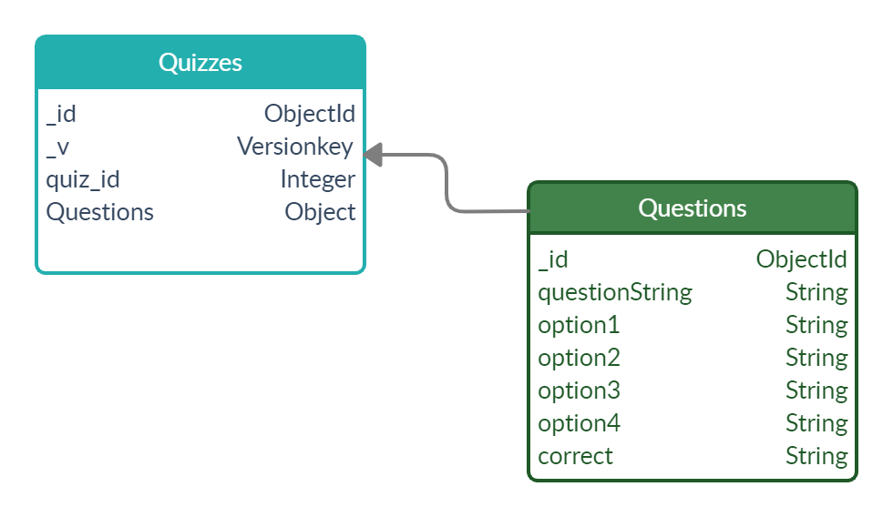

SOME KEY POINTS

* The database document consists of a “Quiz” model and a “Question” model embedded within it.
* The Quiz model consists of 4 attributes out of which _id and _v are auto-generated by Mongodb.
* _id and _v are of datatype objectId and versionKey respectively.
* Another attribute is quiz_id that is provided to every individual quiz
* Question attribute is an Object that has an array consisting questions of a particular quiz in json format.
* Question model has 7 attributes out of which _id is autogenerated.
* Other six attributes are 1 Question string , 4 provided options, and 1 correct option.

### Backup Database schema(Questions)

### 

SOME KEY POINTS

* The database consists of a single objective Question that contains every single question without any grouping.
* The database is simple but not highly indexed as it is not to be used by user or the application for accessing data frequently.
* The database is just going to be used for adding the data and because of which the schema is made as simple as possible.
* The model is almost similar with the embedded model of the main database,the only difference is just an extra quiz_id attribute.

## SUMMARY OF MODULES

### **Home Page:**

This page is responsible for basic operations such as navigation, joining quiz, login page.This is the first page which a user will interact with when he visits **Quiz Mania**.

Currently the homepage consist mainly of two options i.e,

1. To Create A Quiz : Here the user will be allowed add his/her questions and will be able to host a quiz event.
2. To Join Quiz: Here the user will simply enter a code correspond to a quiz

### **Create Quiz Section:**

This section is responsible for creating the Quiz with the help of a Quiz Id which the user has to specify. Then the user is required to input the questions in MCQ format along with one correct answer.After filling the required number of questions, the user can click on Quiz Mania to finally submit all the questions which will be saved in our database. And later on when the candidate has completed his/her quiz then it will return a summary of how many students took the quiz along with their individual scores in terms of percentage.

### **Join Quiz:**

This section is responsible for joining and starting the Quiz. As soon as this option is selected the quiz gets started with each question having a time limit of 30 seconds.Each question consists of four options from which only one option will be the right answer.

## CATEGORIES SECTIONS

### **Home:-**

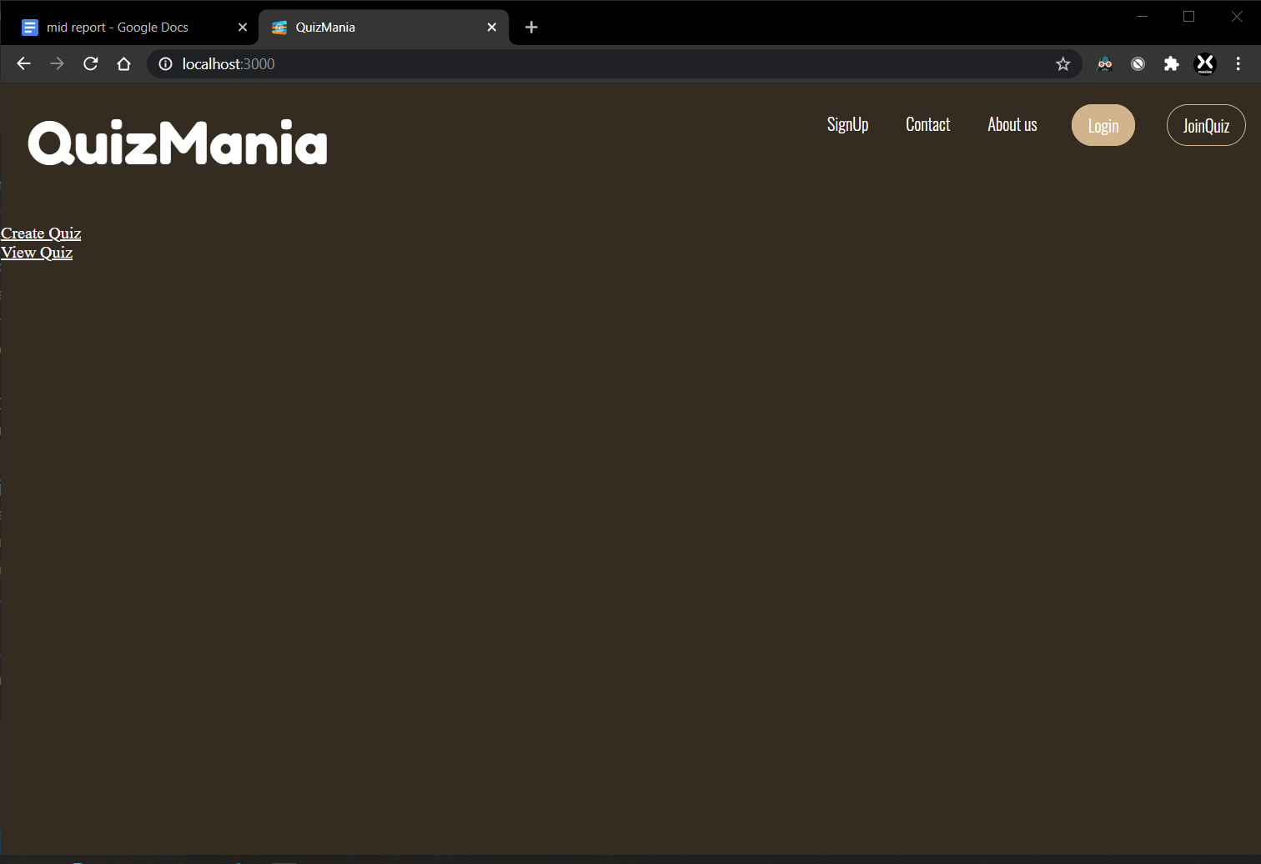

### **Quiz ID :-**

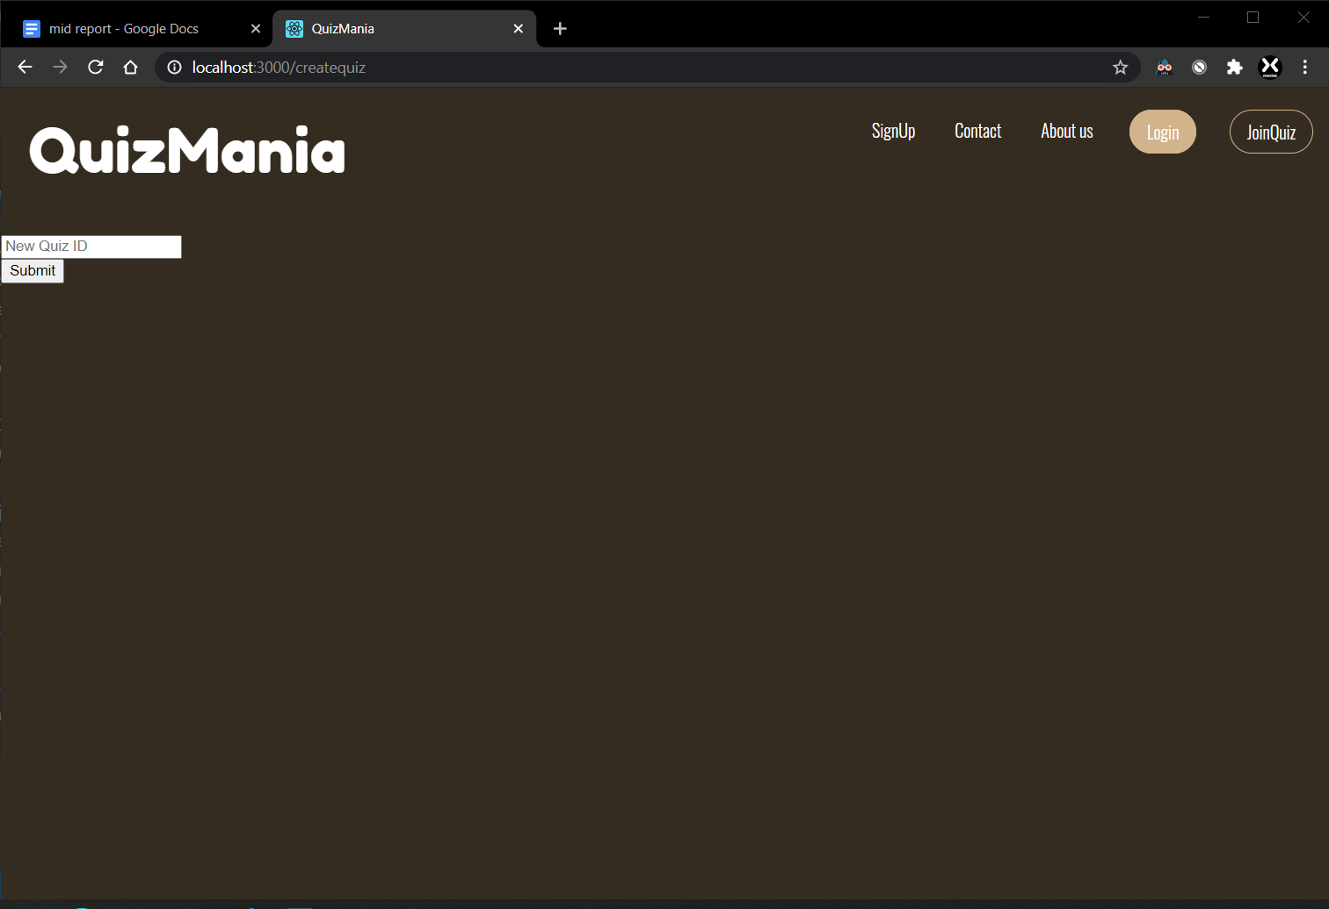

### **Question input :-**

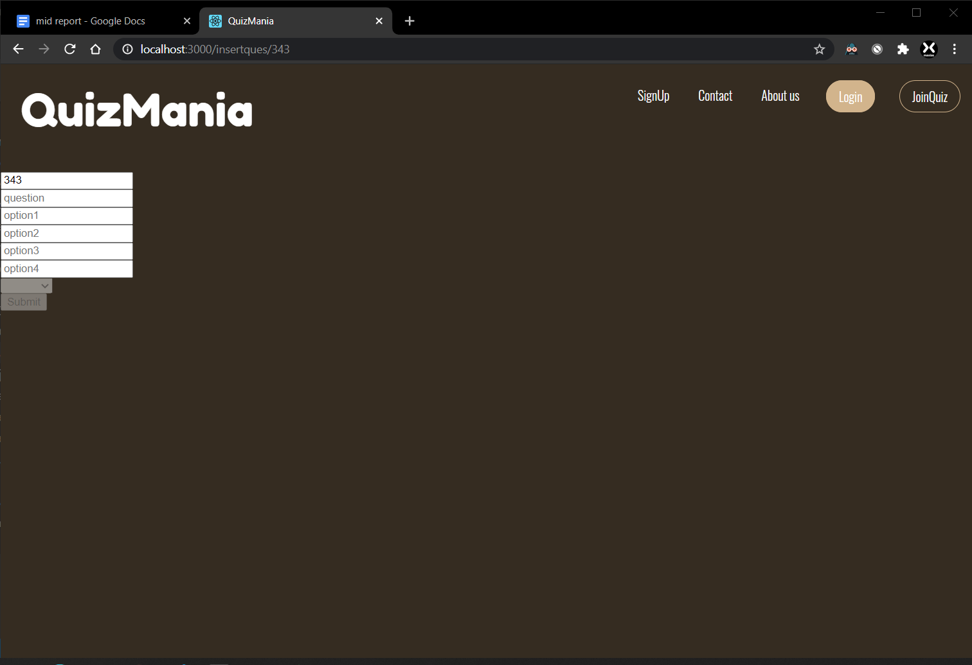

### **View Quiz :-**

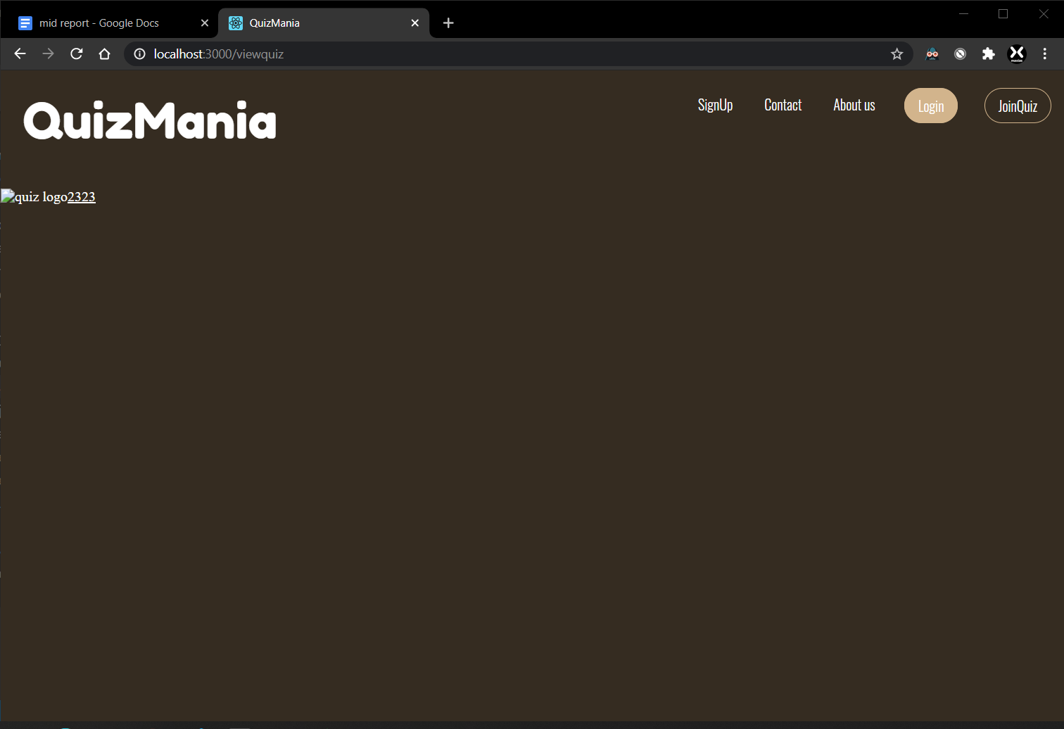

### **Quiz Summary :-**

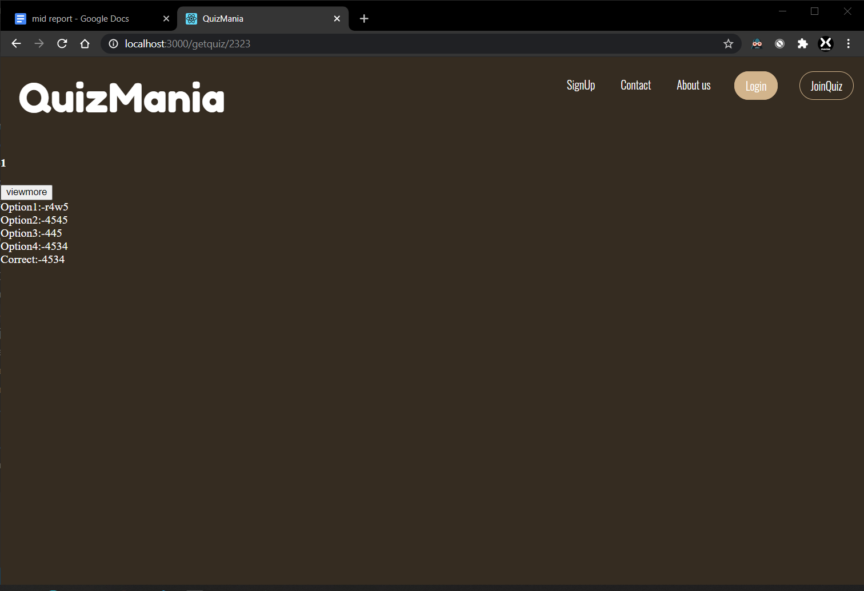

### **Join Quiz :-**

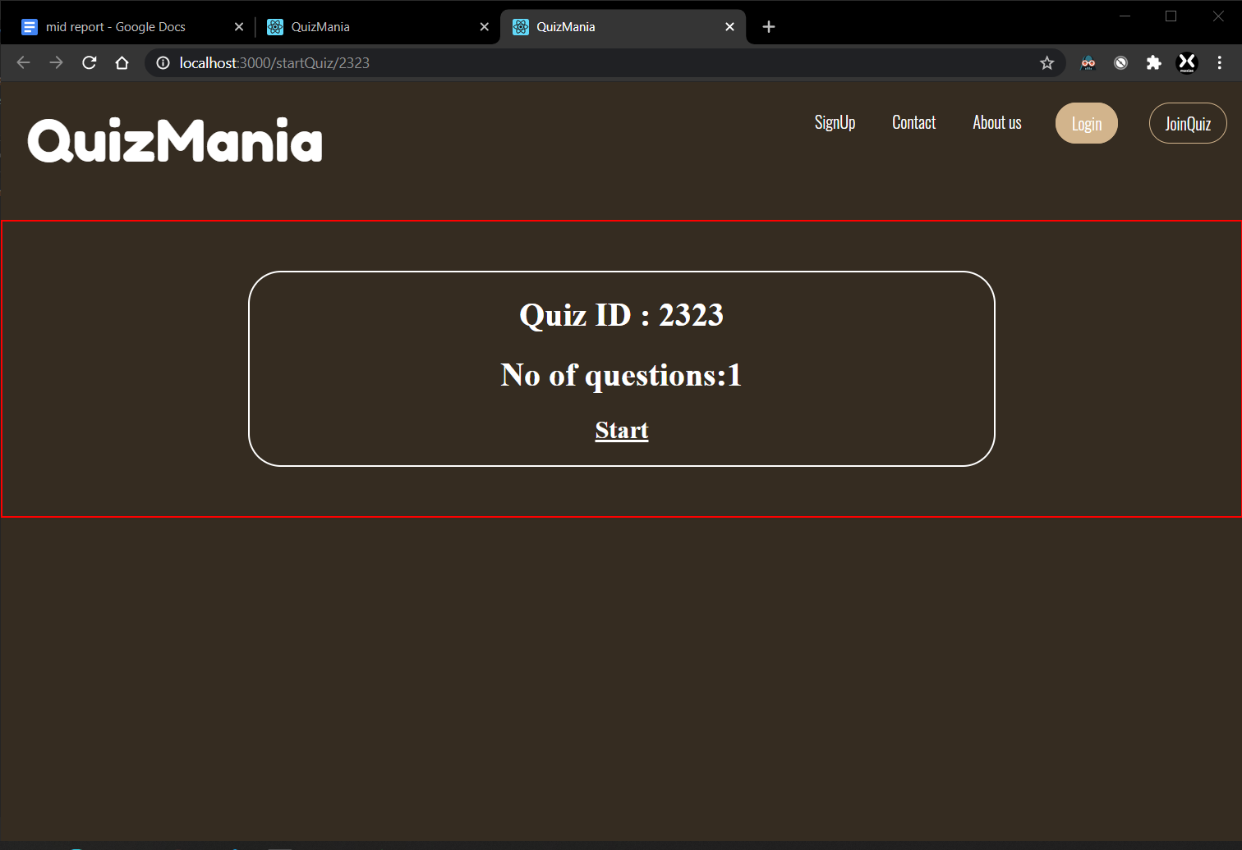

### **Start Quiz :-**

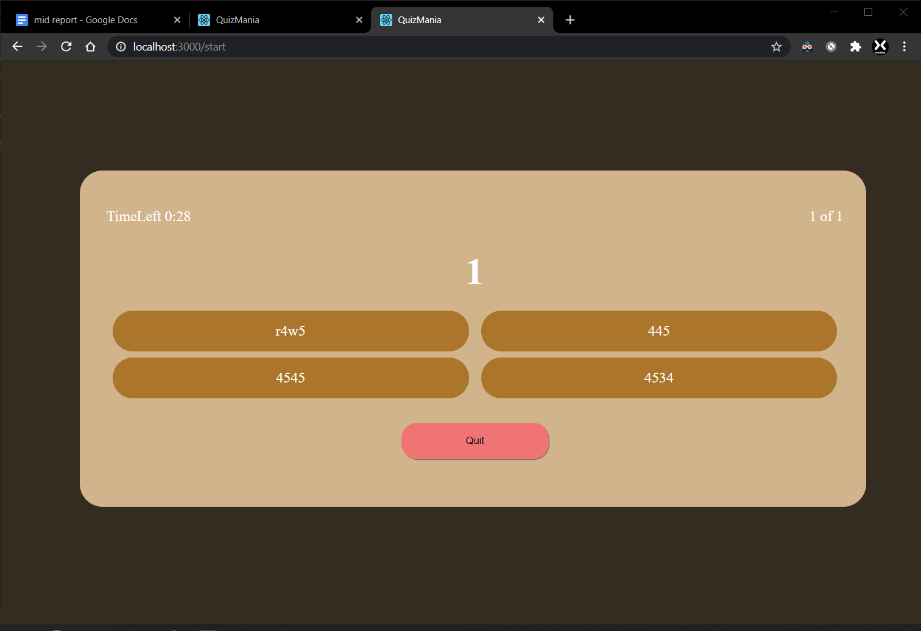

### **Quiz Alerts :-**

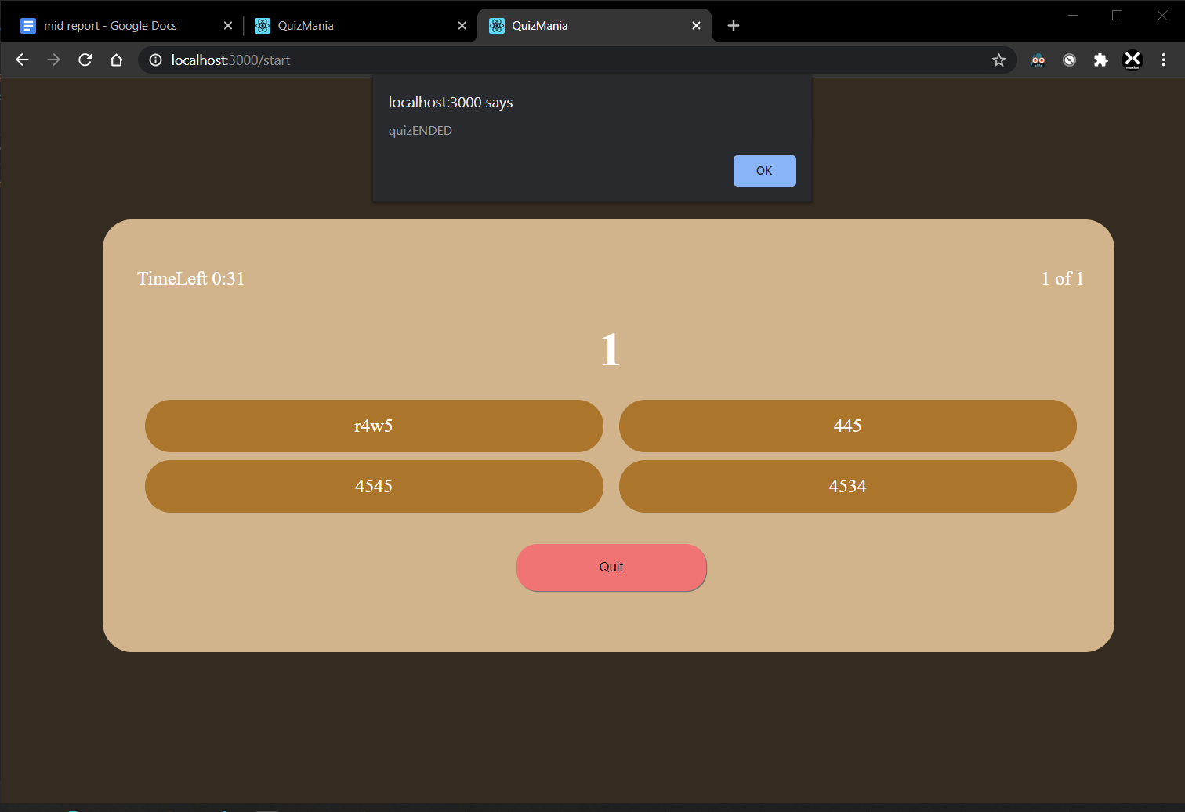

### **Code Snippet**

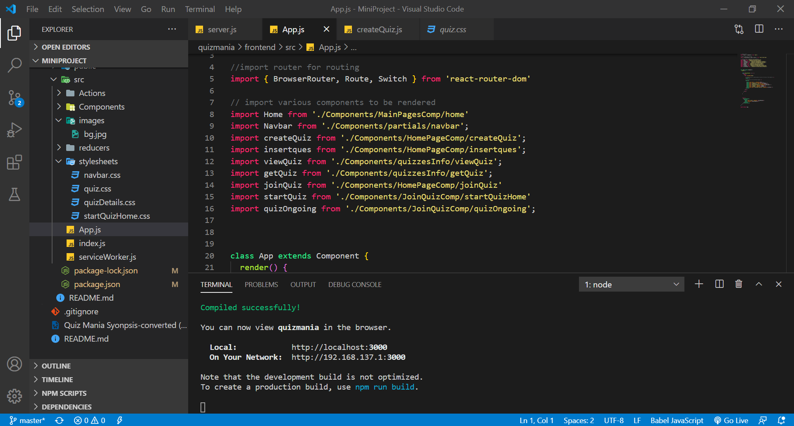

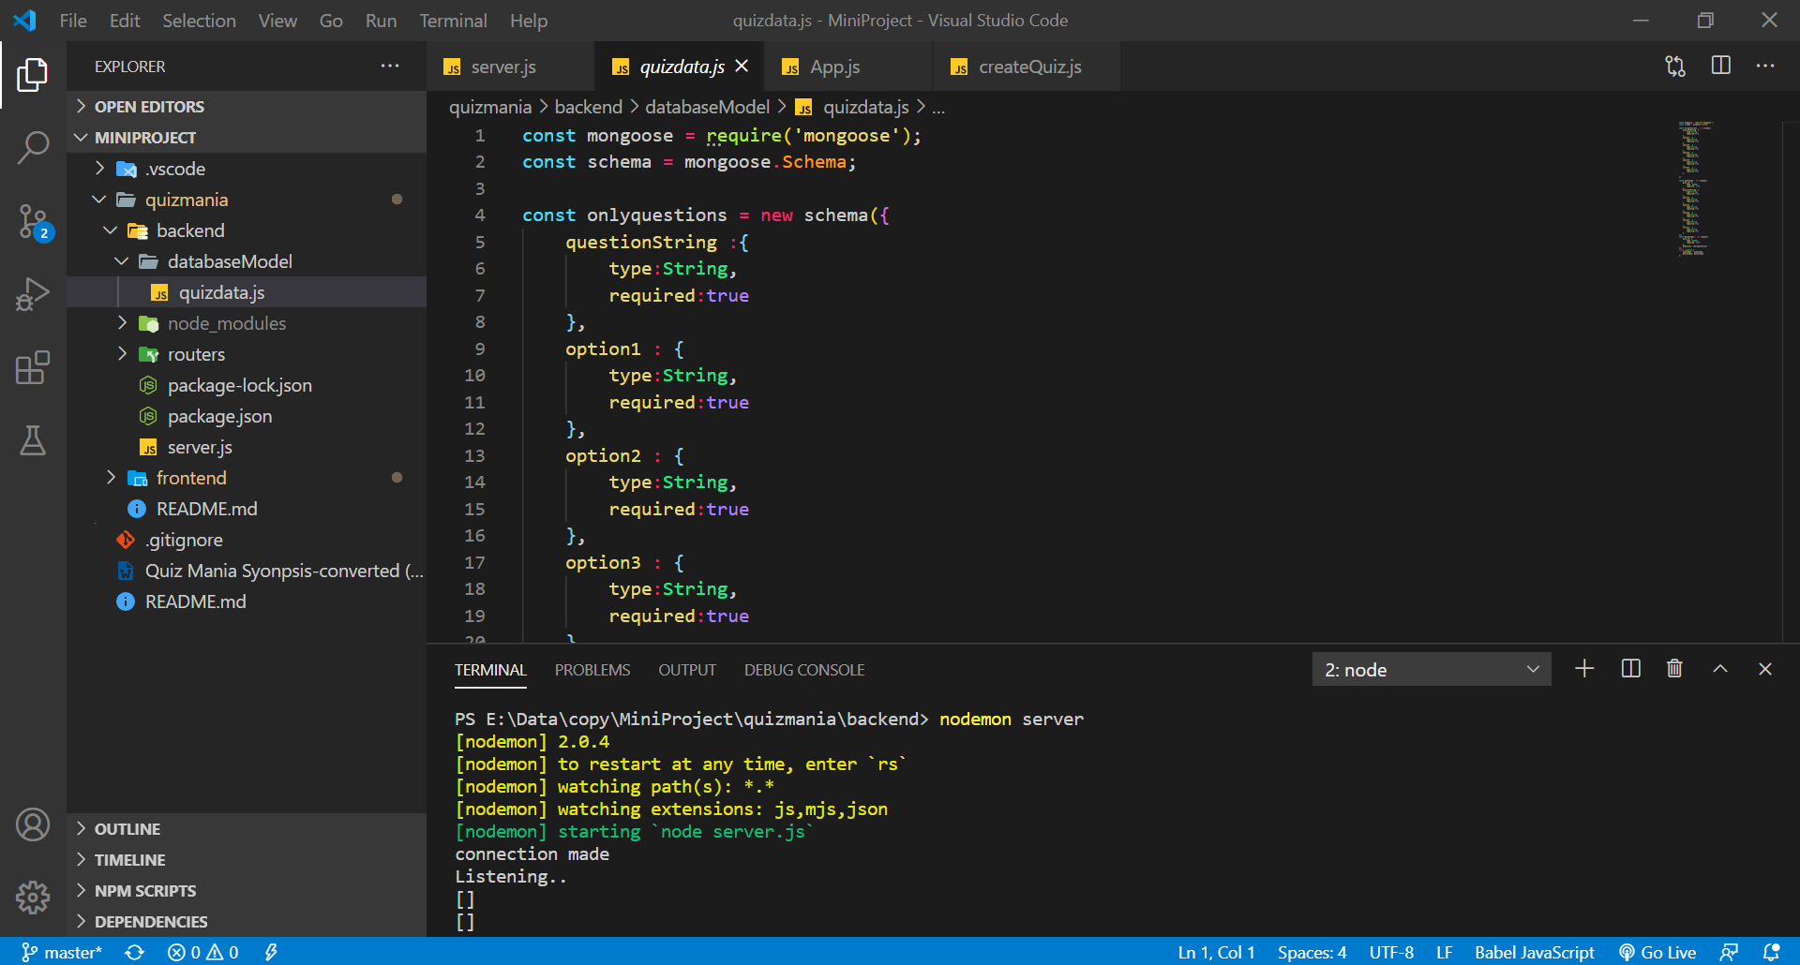

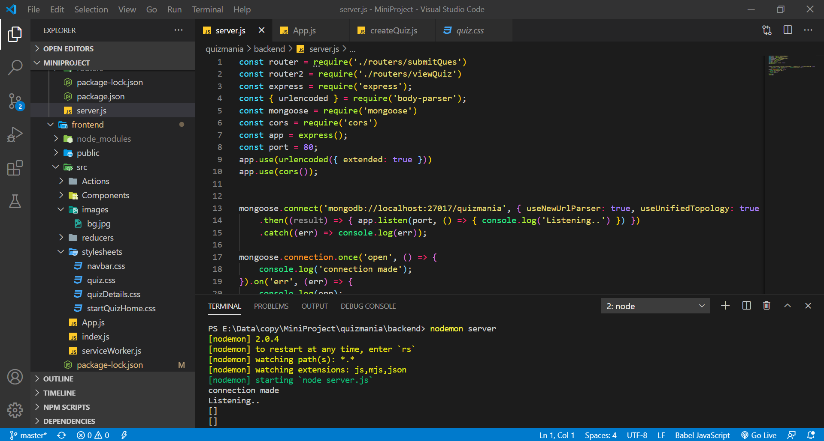

# **Work to be Done**

## Implementation of web sockets for real time users.

## Authentication of user i.e, both signup and logging in of the user.

## Overall styling and representation of Quiz Mania for better user interface.

## 

## 